Ideation Phase
Define the Problem Statements

Date | 24 November 2025
Team ID
Project Name | Flight Booking App
Maximum Marks | 2 Marks

Customer Problem Statement:
Understand the needs, frustrations, and behaviours of travellers’ seeking transparent, low-fee flight booking and operators who require flexible, real-time flight management.
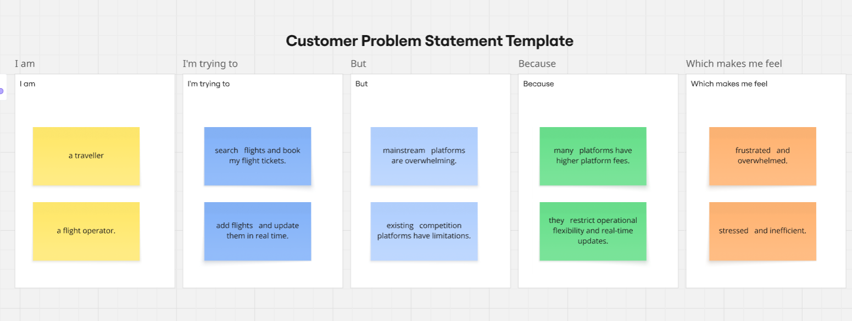
Reference: https://miro.com/templates/customer-problem-statement/

Problem Statement (PS) | I am | I’m trying to | But | Because | Which makes me feel
PS-1 | a traveller. | search flights and book my flight tickets. | mainstream platforms are overwhelming. | many platforms have higher platform fees. | frustrated and overwhelmed.
PS-2 | a flight operator. | add flights and update them in real time. | existing competition platforms have limitations. | they restrict operational flexibility and real-time updates. | stressed and inefficient.

